Plastic Pollution in Oceans
Background:
Plastic pollution is a major environmental issue affecting our oceans. Every year, millions of tons of plastic waste end up in the sea. This pollution harms marine life, from tiny plankton to large whales, and affects ecosystems worldwide.
Current Situation:
According to recent studies, plastic waste makes up a significant portion of ocean debris. Common items include plastic bottles, bags, and packaging materials. These plastics can break into smaller pieces known as microplastics, which are ingested by marine animals and enter the food chain.
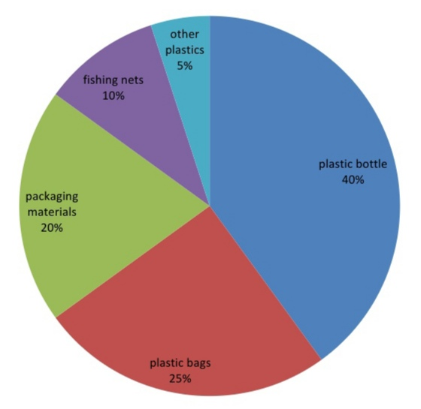
Plastic Waste Composition in Oceans

Impact:
Marine Life:
Animals mistake plastics for food, leading to injuries or death.
Ecosystems:
Microplastics disrupt the balance of marine ecosystems.
Human Health:

Microplastics enter the food chain and can affect human health.
Efforts to Combat Plastic Pollution:
Recycling Programs:
Encouraging recycling reduces the amount of plastic waste.
Beach Clean-ups:
Volunteer groups collect plastic waste from beaches.
Awareness Campaigns:
Educating people about the impact of plastic pollution.
Multiple-Choice Questions
1. What is a major source of plastic waste in the ocean?
A) Wooden planks
B) Glass bottles
C) Plastic bottles
D) Metal cans
2. What percentage of ocean plastic waste is made up of plastic bags?
A) 10%
B) 20%
C) 25%
D) 50%
3. How do microplastics enter the food chain?
A) They float on the surface
B) They are ingested by marine animals
C) They are removed by filters
D) They are decomposed by bacteria
4. Which of the following is NOT a way to reduce plastic pollution?
A) Recycling programs
B) Beach clean-ups
C) Using more plastic bags
D) Awareness campaigns
5. What is one effect of plastic pollution on marine life?
A) Improved health
B) Increased reproduction
C) Injuries or death
D) Enhanced growth
6. What percentage of ocean plastic waste is composed of fishing nets?
A) 5%
B) 10%
C) 15%
D) 20%
7. Which of the following is NOT a common type of plastic waste found in the ocean?
A) Plastic bottles
B) Plastic bags
C) Metal cans
D) Packaging materials
8. Why are microplastics harmful to marine animals?
A) They are easy to digest
B) They provide essential nutrients
C) They can be ingested and disrupt the food chain
D) They are naturally occurring
9. What role do awareness campaigns play in combating plastic pollution?
A) They create more plastic waste
B) They educate people about the impact of plastic pollution
C) They increase plastic production
D) They focus on plastic recycling
10. What is a primary goal of beach clean-up efforts?
A) To promote tourism
B) To increase plastic waste
C) To collect and remove plastic waste from beaches
D) To create new plastic products

